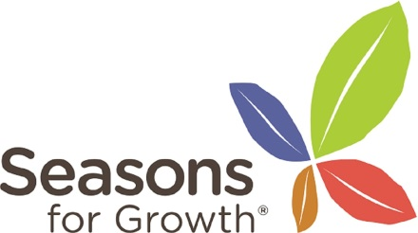
Seasons for Growth Grief Education Companion Training
Date: 25/6/20 9.00 - 4.30
26/6/20 9.00 - 4.30
7/7/20 9.00 - 1.00
About the Training:
To train staff to deliver Seasons for Growth, an accredited loss and grief group intervention for children, young people aged between 6-18 years. Seasons for Growth is a group intervention for those who have experienced a bereavement or any significant loss. The aim is to help participants to manage feelings associated with loss.
Seasons for Growth is a peer group intervention not an individual intervention.
This is a 2.5-day course which must be completed in full and the person trained is the only person who is eligible to use the copyright materials they are trained to use.
Who is it for?
To train ‘companions’ who will go on to deliver the programme and have the endorsement of their managers/organisation they work for to undertake this role. Self-reflection of personal experiences of loss is part of the nature of the course and should be considered before booking.
Cost: £250.00: To include registration and programme manual
Venue: Coed Pella, Conwy Council Offices, Colwyn Bay
To find out how to apply and for further information, please register your interest at val@bont.org.uk

